* **Logistic Regression**

1. **Load the csv file**

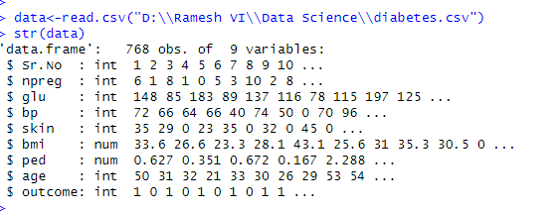

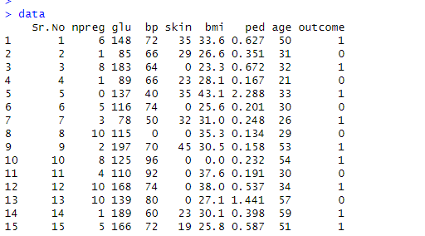

1. **Display the original dataset**

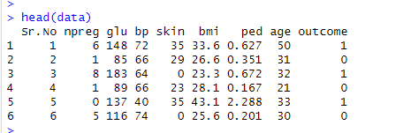

1. **Structure of dataset**

**>**

1. **Convert the 'outcome' variable to a factor**

**data$outcome <- as.factor(data$outcome)**

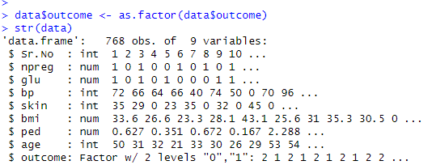

1. **# Split the data into training and testing sets**

**set.seed(123) # for reproducibility**

**train_index <- sample(1:nrow(data), 0.7 * nrow(data))**

**train_data <- data[train_index, ]**

**test_data <- data[-train_index, ]**

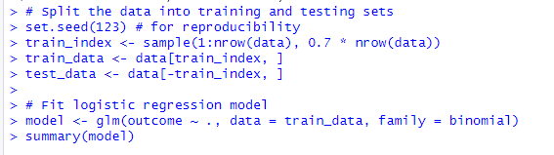

1. **Fit logistic regression model**

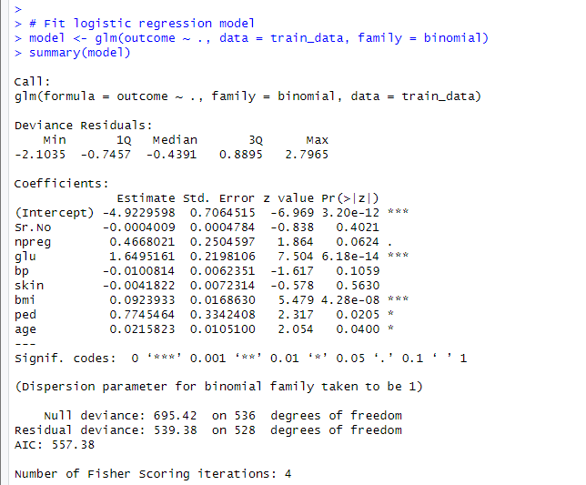

1. **Create confusion matrix for training dataset and finding accuracy**



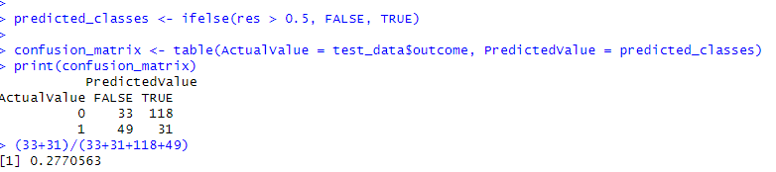

1. **Res**

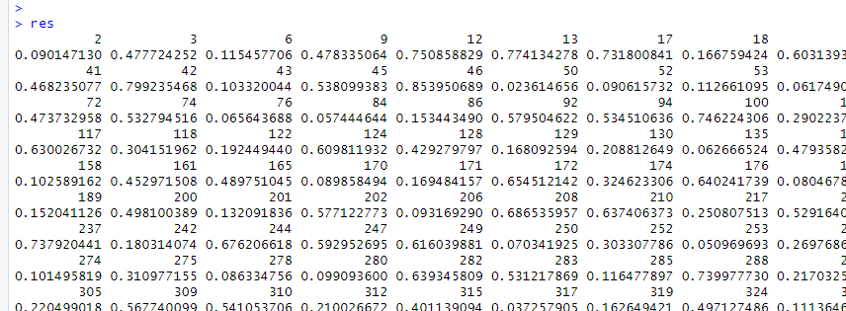

1. **Create table and find the accuracy**

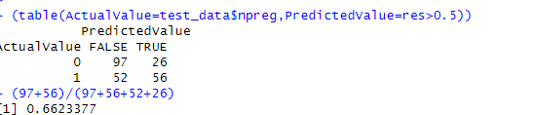

1. **Predict on train_data and find the accuracy**

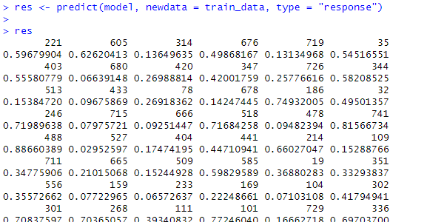

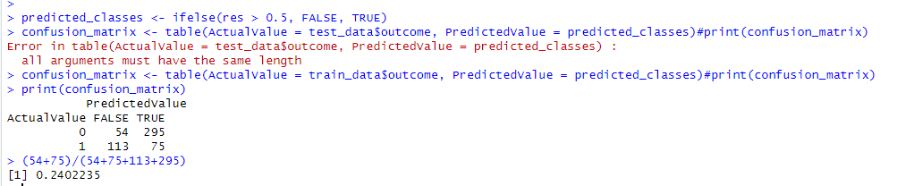

1. **Create table on train data and find the accuracy**

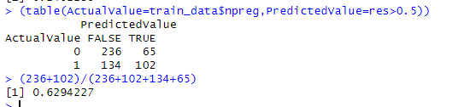

* **Logistic Regression using python**

import pandas as pd

from sklearn.model_selection import train_test_split

from sklearn.linear_model import LogisticRegression

from sklearn.metrics import classification_report, confusion_matrix

# Load the CSV file into a DataFrame

data = pd.read_csv("D:\\Ramesh VI\\Data Science\\diabetes.csv")

# Display the first few rows of the dataset

print(data.head())

# Separate the predictors (X) and the target variable (y)

X = data.drop(columns=["outcome"]) # Assuming "outcome" is the target variable

y = data["outcome"]

# Split the data into training and testing sets

X_train, X_test, y_train, y_test = train_test_split(X, y, test_size=0.3, random_state=42)

# Fit logistic regression model

model = LogisticRegression()

model.fit(X_train, y_train)

# Predict on the testing data

y_pred = model.predict(X_test)

# Evaluate the model

print("Confusion Matrix:")

print(confusion_matrix(y_test, y_pred))

print("\nClassification Report:")

print(classification_report(y_test, y_pred))

